FINE-X Watches

Fine-X Watches is the world’s leading magnificent and outstanding watch making company. It was established in 1996 by B .AJAY (PhD in Arts) who was known also as world’s creative artist. Fine-X company manufactures watches with an unique designs that was never seen before and also it makes remarkable nostalgic watches in present times.

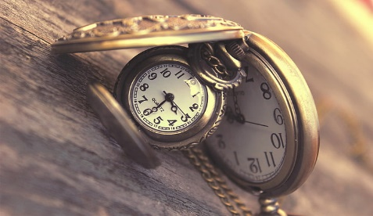

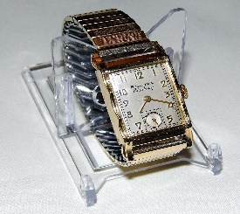

[This Photo](https://commons.wikimedia.org/wiki/File:Vintage_Bulova_Excellency_Manual_Wind_Watch,_10_K_Gold_Fill,_21_Jewels_(9208631728).jpg) by Unknown Author is licensed under [CC BY-SA](https://creativecommons.org/licenses/by-sa/3.0/)

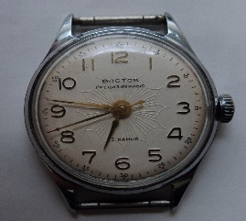

[This Photo](https://ussr-watches-cccp.blogspot.com/p/russian-watches.html) by Unknown Author is licensed under [CC BY-NC-ND](https://creativecommons.org/licenses/by-nc-nd/3.0/)

The following representation shows enterprise structure

Client

Fine-X watches

Plant 1 plant 2

Leather, Steel, Gold, Silver Internal Mechanical Gear Parts

Cross plant purchasing organisation

Purchasing Group

P2p Cycle(procurement to pay cycle) The last step of P2P cycle ends with the process of “Invoice processing and Vendor Payment”.

Different Procurement methods.

1.Direct Material Procurement

Here, In this method materials like gold, steel, titanium, leather, Silver, Glass

which are used for making parts of the watch are directly fetched through Direct Procurement methods.

2.Consignment Procurement

Some kind of basic materials are procured from vendors and stored in the warehouses of the company and used when required. And payment is only done to vendor when the materials are used by the organization.

3.Service Procurement

Some services like Cleaning, Repairs are requested by the organization for proper maintenance of company and also for the proper functioning of machines.

4.Pipeline Procurement

Water supply for the company is essential since metallurgical processes are involved in making and moulding different materials like gold, steel ,titanium into different shaped and sized minute watch parts. Water is used rapid cooling for machines sometimes.